**JOHN ADRIAN E. ADONA 11-19-2023**

**DSA MS SQL SERVER MASTERCLASS**

**SQL: FINAL PROJECT DOCUMENTATION**

1. **INTRODUCTION**

In the realm of relational database management, the ability to organize and query data efficiently is paramount. This project embarks on a journey to harness the power of Microsoft SQL Server, employing the insights gained from the MS SQL Server Masterclass Bootcamp. Our primary objective is to migrate the SuperStore Excel dataset into an MS SQL Server database, transforming it into a well-structured schema with multiple SQL tables. The project encapsulates the comprehensive utilization of Data Manipulation Language (DML), Data Control Language (DCL), Data Query Language (DQL), and Data Definition Language (DDL) operations. Through this endeavor, I aim to showcase the practical application of database management concepts and provide a comprehensive documentation of the process, methodologies, and outcomes achieved. Let's delve into the intricacies of database manipulation and unveil the potential within the Microsoft SQL Server ecosystem.

1. **PROBLEM STATEMENT**

The main task for this project is to transfer the chosen file, the SuperStore Excel dataset, to the MS SQL Server database with multiple SQL tables, incorporating all the lessons learned from MS SQL Server Masterclass Bootcamp, using the following operations:

* Data Manipulation Language (DML)
* Data Control Language (DCL)
* Data Query Language (DQL)
* Data Definition Language (DDL)

**INPUT FILE: SUPERSTORE EXCEL FILE**

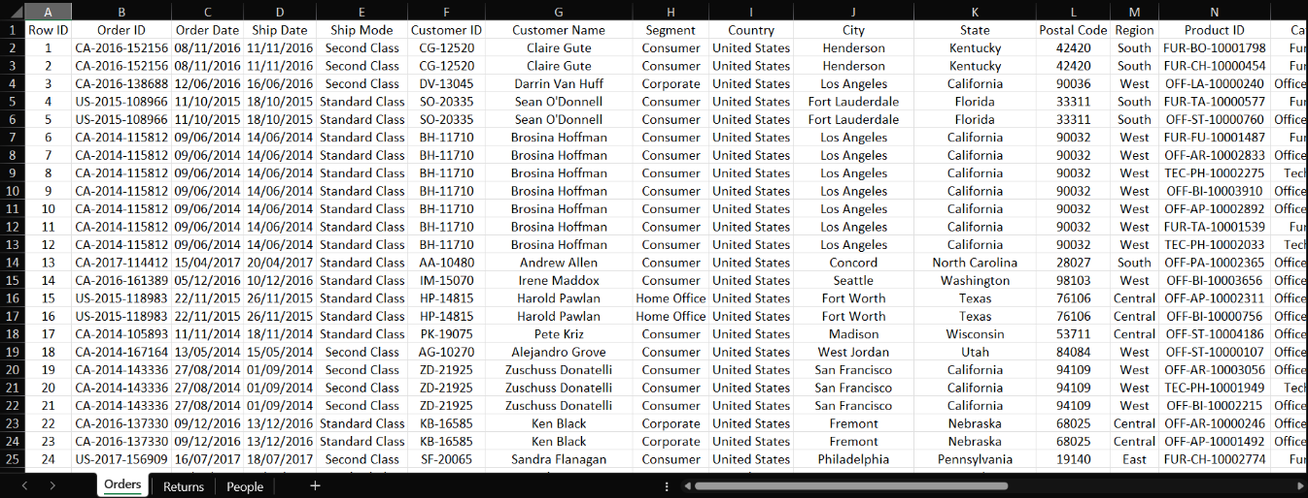

1. **METHODOLOGY**

**INSERTING THE SUPERSTORE EXCEL FILE FOR TRANSFORMING**

To start with, I created temporary tables to store the SuperStore data temporarily and assist in transforming the data into multiple SQL tables, assigning the respective data types to each column. I used the **BULK INSERT** clause to store the SuperStore data. I named these temporary tables–**Orders_Temp, Returns_Temp** and **People_Temp** respectively.

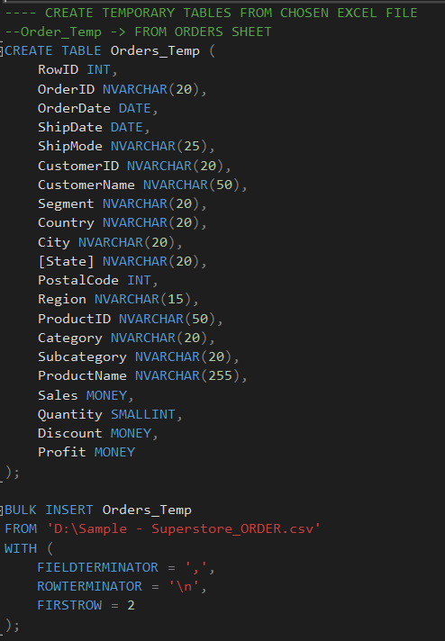

I created another temporary table, **#Temp_Gender**, based on the customers’ names to determine their gender since the SuperStore data doesn’t have gender information. I categorized the customers’ gender based on the collection of Popular Baby Names data from the US Social Security Administration’s official website, which I collated using Excel Power Query. You can find the Popular Baby Names data right here at this URL address: <https://www.ssa.gov/oact/babynames/limits.html>.

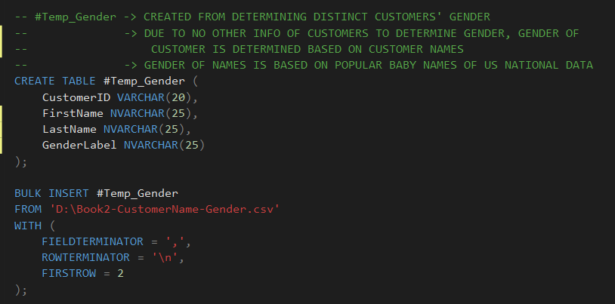

**#Temp_Gender Data**

**TRANSFORMING DATA TO MULTIPLE SQL TABLE**

* **DimProducts**

Starting with the creation of the Products table (**DimProducts**), I created a table for the Products table and checked for the columns that I will include in the table for duplicates in the ProductIDs and Product Names. Discovering that there were indeed existing duplicates, I made the following actions to remedy this issue:

* After creating the Products table, **I wrote a SQL query to determine the distinct** **ProductIDs** from the temporary **Orders_Temp** tableand **saved the query as a VIEW entitled, DistinctProducts**.

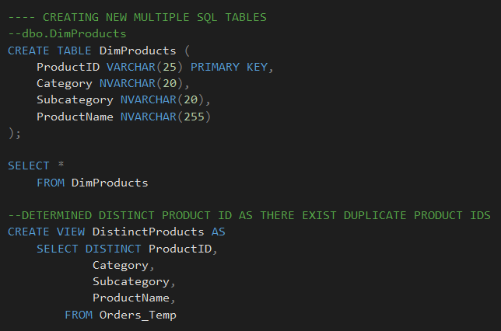

* Using the newly saved SQL VIEW, I performed series of SQL queries to **determine which of the ProductIDs and Product Name appear more than once** and then I **adjusted them to make them unique**. I saved the result into a VIEW named as **UniqueProductIDCount.**
  + I created first a common table expression or CTE, naming it as **ProductIDCount** and displaying the count of unique ProductIDs and Product Names appearing in the data using the following functions and naming them **RowNum** and **ItemCount**, respectively:
    - **ROW_NUMBER() :** Generates a number sequence for each row.
    - **OVER:** Define the scope where the function *(ROW_NUMBER())* operates, consisting of the **PARTITION BY** and **ORDER BY** clauses.
    - **PARTITION BY ProductID:** This establishes the partition for each unique value in the **ProductID** column, ensuring that row numbers restart for every unique ProductID.
    - **ORDER BY (SELECT NULL):** This establishes the order for the function *(ROW_NUMBER())* but since I didn’t need to specify an order, I inputted it as **NULL.**

* + After creating the **ProductIDCount**, I used the **LEFT JOIN** clause to combine it with the created **DistinctProducts VIEW** to change the duplicate ProductIDs to a new one, making a brand-new column named **UniqueProductID**. Afterwards, I saved the whole SQL query into a VIEW named **UniqueProductIDCount**.

* + - I incorporated the CTE that I created inside a **CASE** clause, specifically the **RowNum** column, to make the changes on the duplicate ProductIDs or those that appeared more than once while not changing the other ProductIDs that are unique already. In this case, I only added 1,000,000 to the numeric part of the ProductID. Here is a sample from one of the duplicate ProductIDs:

* Finally, I inserted the relevant **UniqueProductIDCount** VIEW columns to the **DimProducts** table that I initially created. Afterwards, I adjusted and provided the primary key constraint of the DimProducts table with a new name, **PK_Products_ProductID**.

* **DimCustomers**

Creating the DimCustomers table also involved some of the process that I did in the DimProducts table, starting with creating the table itself. The rest of process went on as follows:

* After creating the DimCustomers table, I made a SQL query to determine the **unique customer names** from the Orders_Temp table, saving the query into a VIEW named as **DistinctCustomers**.

* I inserted the relevant data from the DistinctCustomers VIEW and the Gender information of the customers from the temporary #Temp_Gender table to the DimCustomers table with the use of **JOIN** clause. I also applied two **CASE** clauses to **convert the customer names** from the DistinctCustomers VIEW into **columns for customers’ first and last names**, named as **FirstName** and **LastName** respectively.

* + For the condition inside the CASE clauses, I decided to **split the first name and the last** name of the customers **using the space (‘ ‘)** as the basis where I should split the name. I implemented the **CHARINDEX** clause to determine the position of the space. If MS SQL Server finds the space, I can extract the customers’ first names and the last names. If it could not find the space, I resorted to just input the whole customer’s name to the **FirstName** column.

* + As for extracting the first names and last names, I used other SQL clauses:
    - **CHARINDEX():** To search for the position of a specific character - in this case, the **space (‘ ‘).**
    - **LEFT():** To extract the characters starting from the left side up to a specific character/position where I incorporated the **CHARINDEX** clause here as the end of the return output. These results return the **first names** of the customers.
    - **RIGHT():** Like the **LEFT** clause, this also extracts the characters, but it starts from the right. Same as before, I incorporated the **CHARINDEX** clause here as the end of the return output. These results return the **last names** of the customers.
    - **LEN():** This determines the length of the characters, showing how many characters are used per each observation. I used this to dynamically determine the full length of each customers’ name, helping me determine the location of the space to extract the last names of the customers.

Before adjusting the primary key constraints, I performed a data validation first to truly see if there were any mistakes made along the way, in which I found two:

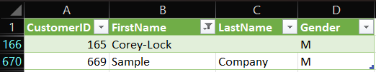

Normally, issues like data discrepancies on customer information should be treated with caution, but since this is just sample data, I decided to create the changes myself directly in the SQL queries. Using the **UPDATE** clause, here are the changes I made with further SQL query information below:

* One customer was named **“Sample Company A”**. I changed it to another name, **Azrael Callisto**.
* One customer, named **“Corey-Lock”**, was not transformed into first and last names due to using a **dash ( - )** as a delimiter instead of the ***space* that I used as the delimiter reference in my CASE clauses**. I decided to split the name manual via UPDATE clause (**First Name:** *Corey***, Last Name:** *Lock*).

* **DimPeople**

Since the data that I will input in the DimPeople table is already in a temporary table (**People_Temp**), the process was straightforward in this one without creating any SQL views. The only thing to note is that I inserted a primary key to the DimPeople table (**RegionID** since the does not have any data that I could use as a unique ID via the **IDENTITY** parameter that one can include inside the **CREATE TABLE**) clause. Therefore, I generated a random numeric unique numbers as primary key for the DimPeople table.

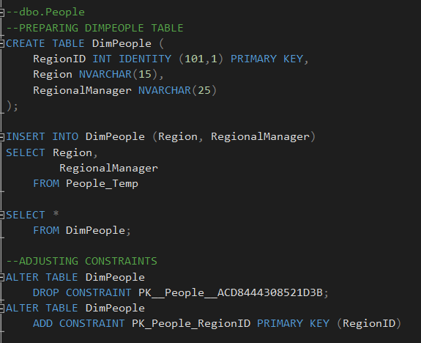

* **DimCustomerDetails**

Using the temporary table, **Orders_Temp**, I retrieved the unique details that I will input to the DimCustomerDetails table alongside the **RegionID** primary key column from the DimPeople table using the combination of saved SQL VIEW, INSERT INTO clause and JOIN clause. Then, I adjusted the primary and foreign key constraints for the DimCustomerDetails table in the way I see fit.

**CREATING OVERALL DATA VIEW IN A SQL VIEW**

Before proceeding with the other SQL tables, I decided to create a SQL query containing some of the created SQL tables, **DimCustomerDetails, DimPeople** and **DimProducts**, joined together alongside the temporary tables, **Orders_Temp** and **Returns_Temp**, and saved as a SQL view. This view, named **OverallSuperStoreData**, was created to better help me in creating the other SQL tables.

**CONTINUATION: TRANSFORMING DATA TO MULTIPLE SQL TABLE**

* **DimOrders**

I created the DimOrder table and input the unique data from the **OverallSuperStoreData** SQL view. Aside from the usual process that I did with the other SQL tables, here are the other things that I did:

* I discovered that the OrderID used in the original SuperStore data is not unique/distinct if I were to connect them with the DimProducts data (**same OrderID is used to same customer but with different products order**). I decided to give a new OrderID using the **UNIQUEIDENTIFIER** data type in CREATE TABLE clause.

* I decided that I wanted to include a RegionID foreign key from the DimPeople table, but I already created the DimOrders table. I used the **ALTER TABLE** to **ADD** the RegionID column to the table and **UPDATE** it with the help of **INNER JOIN** clause. As validation, I checked the results using the **COUNT()** function to see if there would be shown results. Afterwards, I modified all the foreign and primary keys of the DimOrders table.

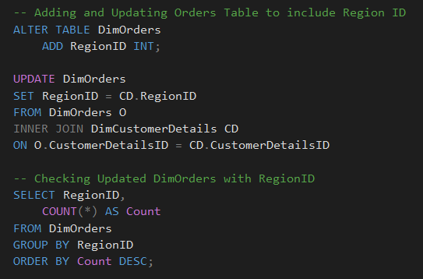

* **DimReturns**

Like in the DimPeople table, I created a primary column (**ReturnID**) since the temporary table, **Returns_Temp**, also does not have that kind of data. I had trouble connecting the DimReturns table to DimOrders table since the DimReturns table uses the original OrderID which I already changed in the DimOrders table. Therefore, I used a **JOIN clause with multiple column references** from the DimOrders table as an alternative to a primary key to connect with. As a finishing touch, I set an UPDATEclause to change all NULL values from the results that are not returned into “No” since the Returns_Temp only has data for returned orders.

**INTEGRATING DIMRETURNS TABLE TO DIMORDERS TABLE**

Upon further deliberation, I decided to not make DimReturns table as a standalone table since aside from the unique IDs, it only contains data where an order is returned or not. Therefore, with the aid of **ALTER TABLE**, **UPDATE**, **JOIN**, and **CASE** clauses, I updated the DimOrders table to include the DimReturns data under the column name, **“IsReturned”**.

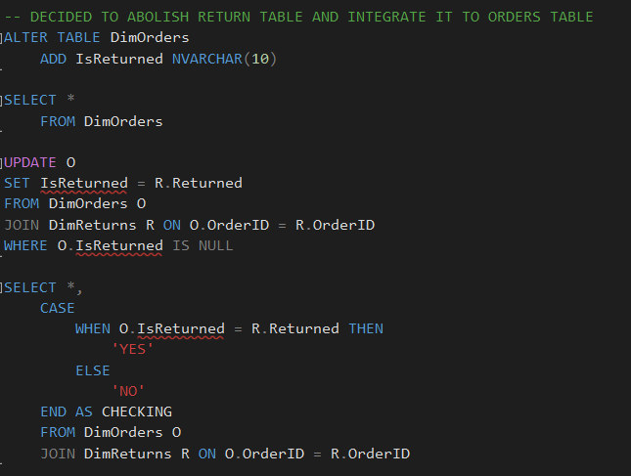

* **FactOrderSales**

I also used the same concepts as the previous SQL tables that I created. After retrieving the unique information from the OverallSuperStoreData SQL view, I created an OrderSalesID column to add a unique primary key using the IDENTITY parameter. Also like in the DimReturns table, I made use of multiple column references from the DimOrders table to connect FactOrderSales to DimOrders. In addition, I also included a RegionID foreign key a little too late, so I inserted it in the same way I inserted the RegionID in DimOrders, before finishing off with the primary and foreign key constraints adjustments.

After creating all the SQL tables, I deleted all the temporary tables and SQL views that I created for the sake of data processing. The #Temp_Gender table is not included here because that table will be gone eventually since it is truly a temporary table and is not permanently saved in the MS SQL Server database. Of course, I backed up my SQL database first before dropping all these tables in case there is something I need to change within the database in the future.

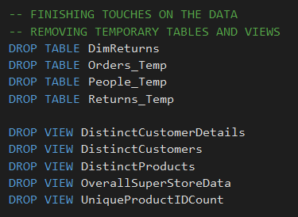

**ADDING USERS AND SECURITY USING DATA CONTROL LANGUAGE**

With the aid of ChatGPT, I created five different roles for my newly created database with each role representing a hypothetical team that will access my database.

I decided to grant the following roles access permissions to the following tables, with the guidance of ChatGPT on which SQL tables provide access to.

With that out of the way, I conceptualized and brainstormed at least four (4) users with different hypothetical job roles and logins for each created team roles. One by one, I inserted them to their respective teams.

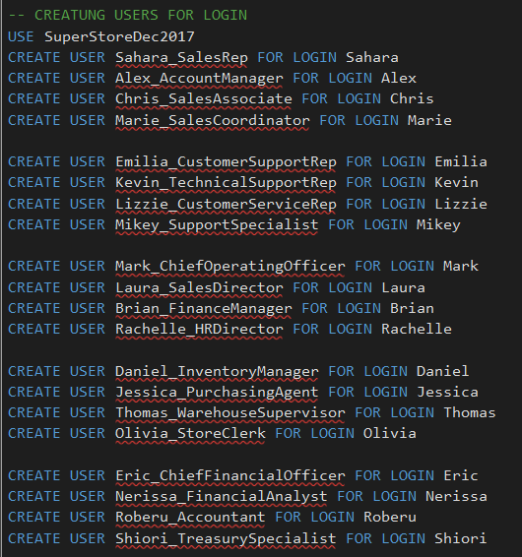

As finishing touches, I also gave user permissions to those who need more than what access was given to their respective teams. ChatGPT also aided me in conceptualizing which users need more access permissions aside from the ones provided per each team.

1. **RESULTS**

**SQL TABLE DATABASE**

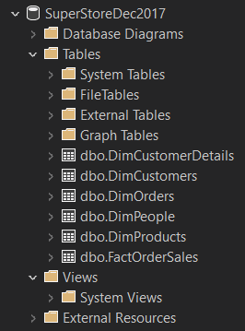

**DimCustomerDetails**

**DimCustomers**

**DimOrders**

**DimPeople**

**DimProducts**

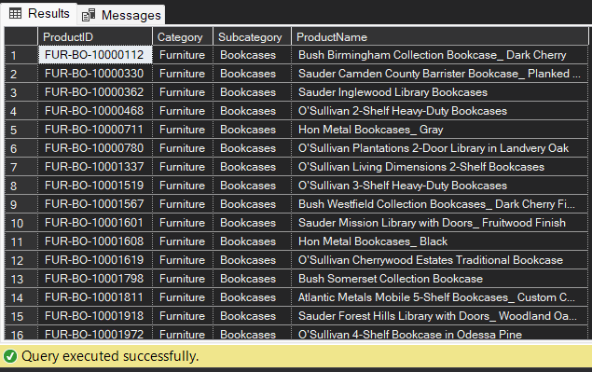

**FactOrderSales**

